|  |
| --- |
| EPAM Systems, RD Dep., RD Dep. |
| MTN.*NIX.01 Installing and Configuring CentOS 6.x\7.x  (GNU/Linux, RedHat based distributions)  MTN.*NIX."Applications support for *NIX " |

|  |  |  |  |  |  |
| --- | --- | --- | --- | --- | --- |
| REVISION HISTORY | | | | | |
| Ver. | Description of Change | Author | Date | Approved | |
| Name | Effective Date |
| <0.1> | New | Maksim Yaremka | <25-May-2017> |  |  |
|  |  |  |  |  |  |

1. Login to centos7 vm as root

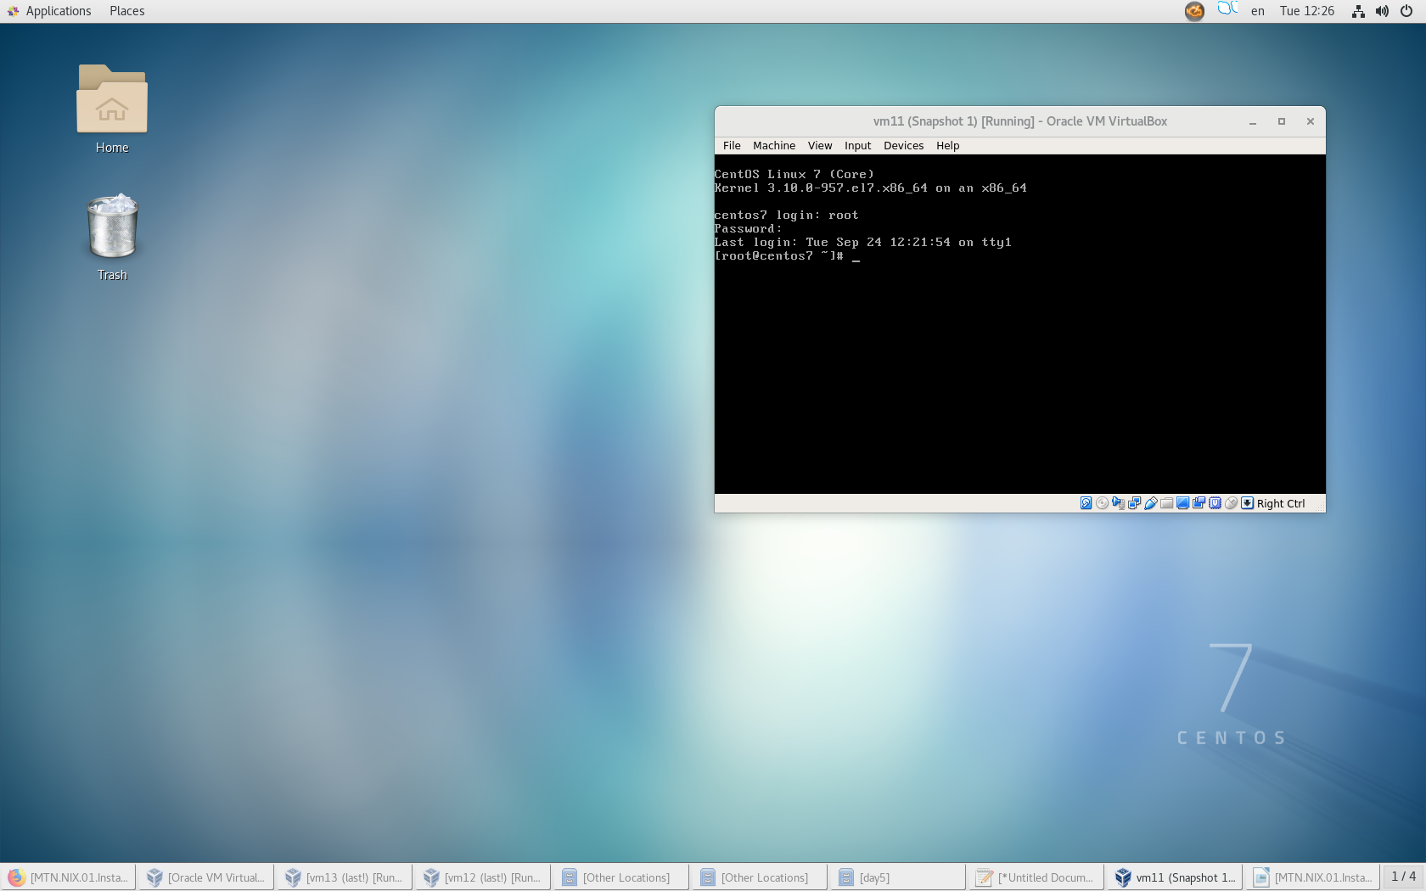

1. Create user Name_Surname with private group, UID = 505, GID=505

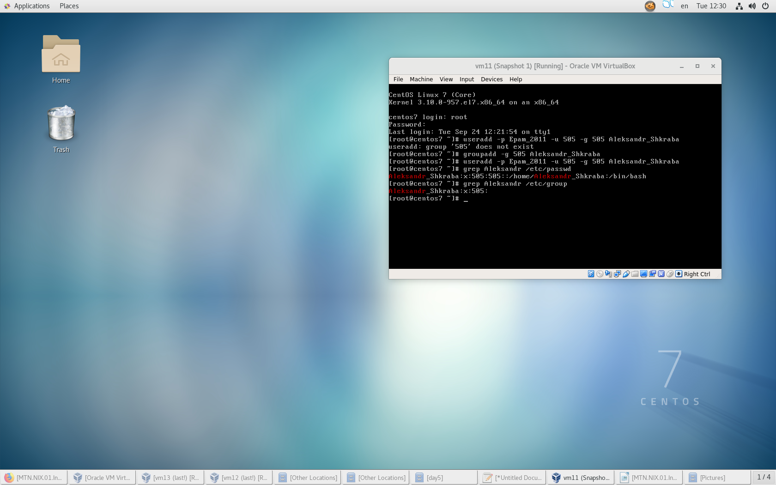

1. Create SSH key pair from local user to [Name_Surname@centos7](mailto:Name_Surname@centos7)

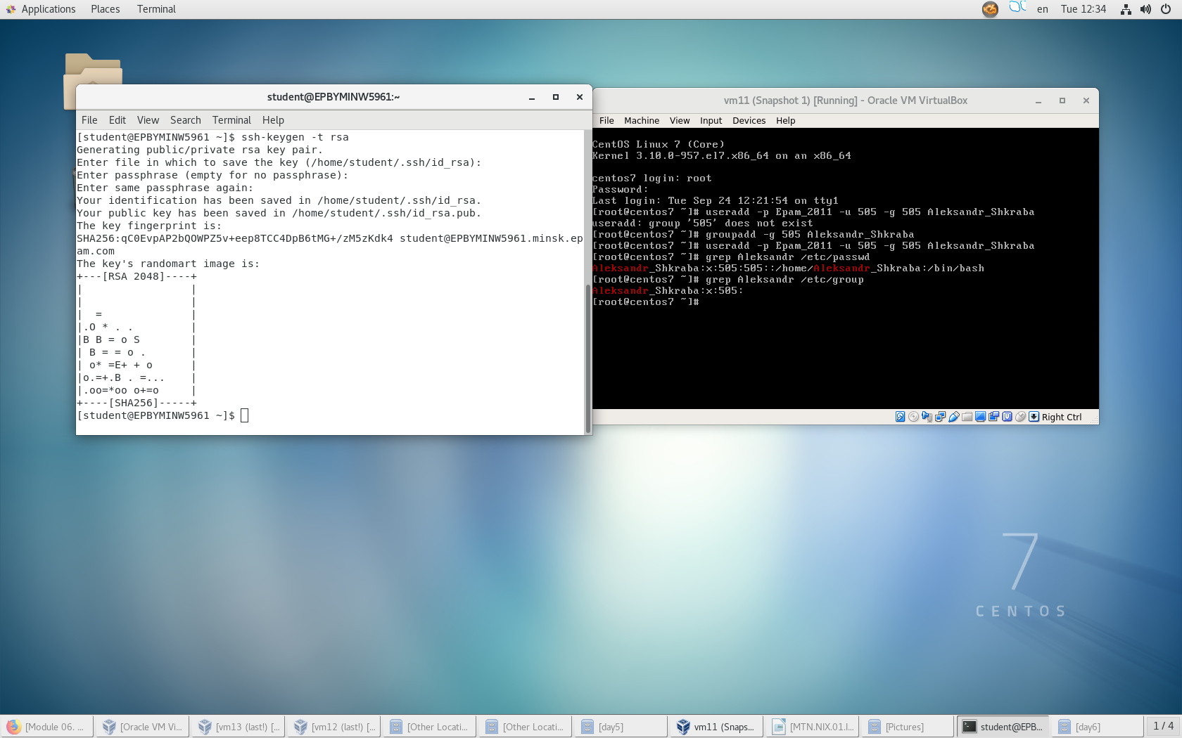

1. Login on centos7 vm without passwd,

* (server side logging) find the log entry for it on centos7vm:

Accepted publickey for user from 127.0.0.1 on port xxxxx ssh2

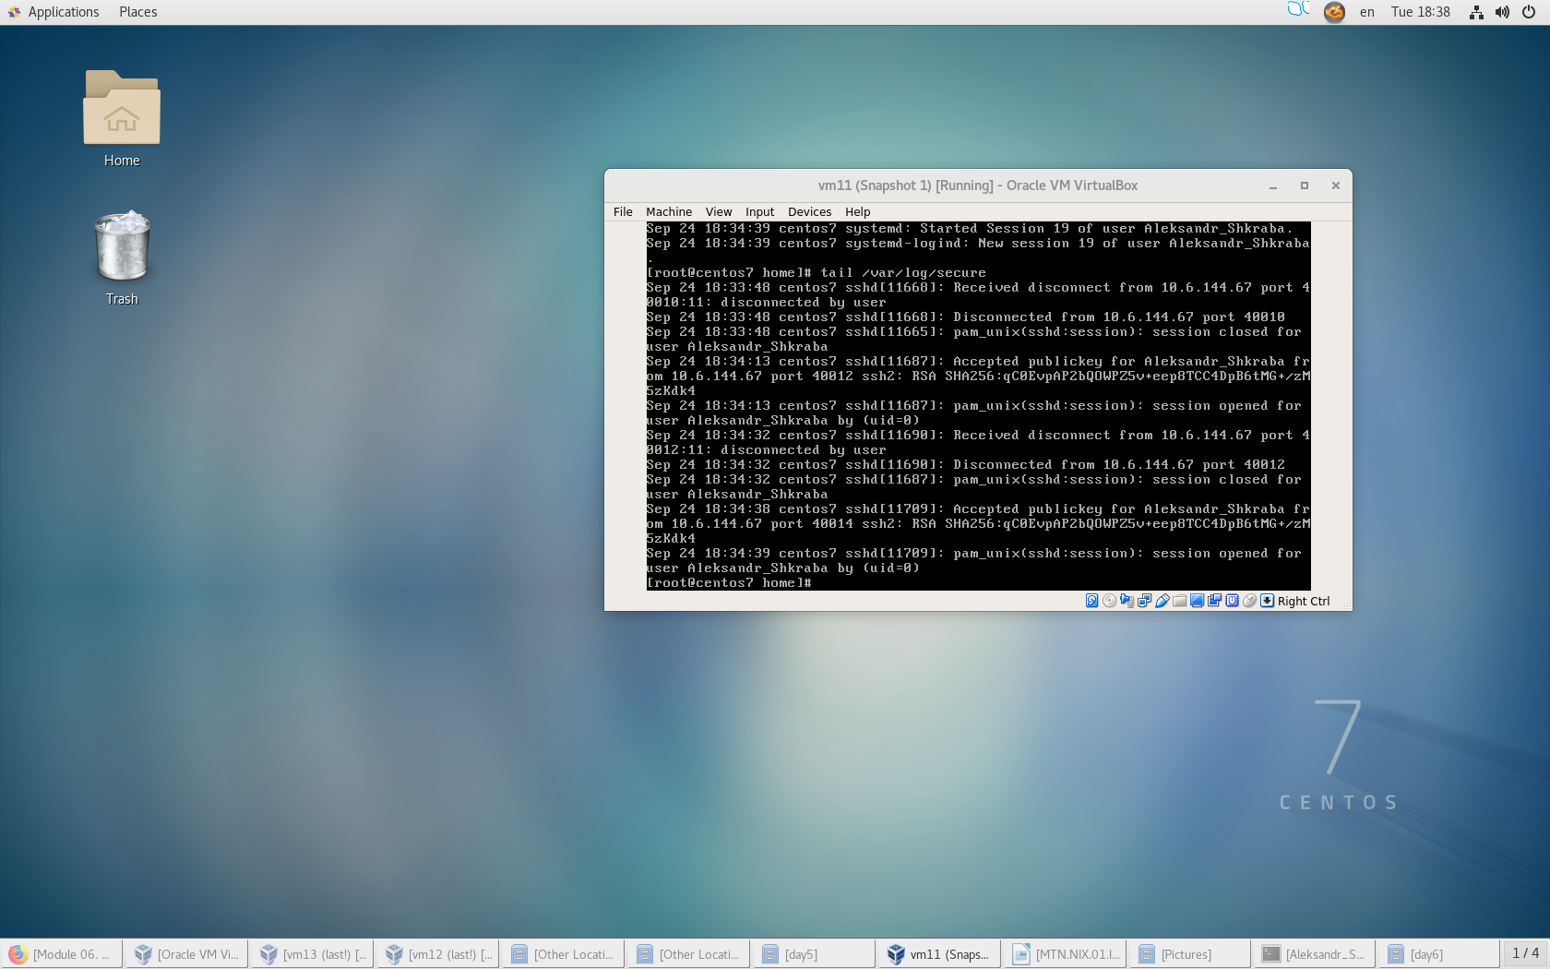

* (client side logging) provide corresponding entries from ssh output on local host:

debug1: Next authentication method: publickey

debug1: Authentication succeeded (publickey).

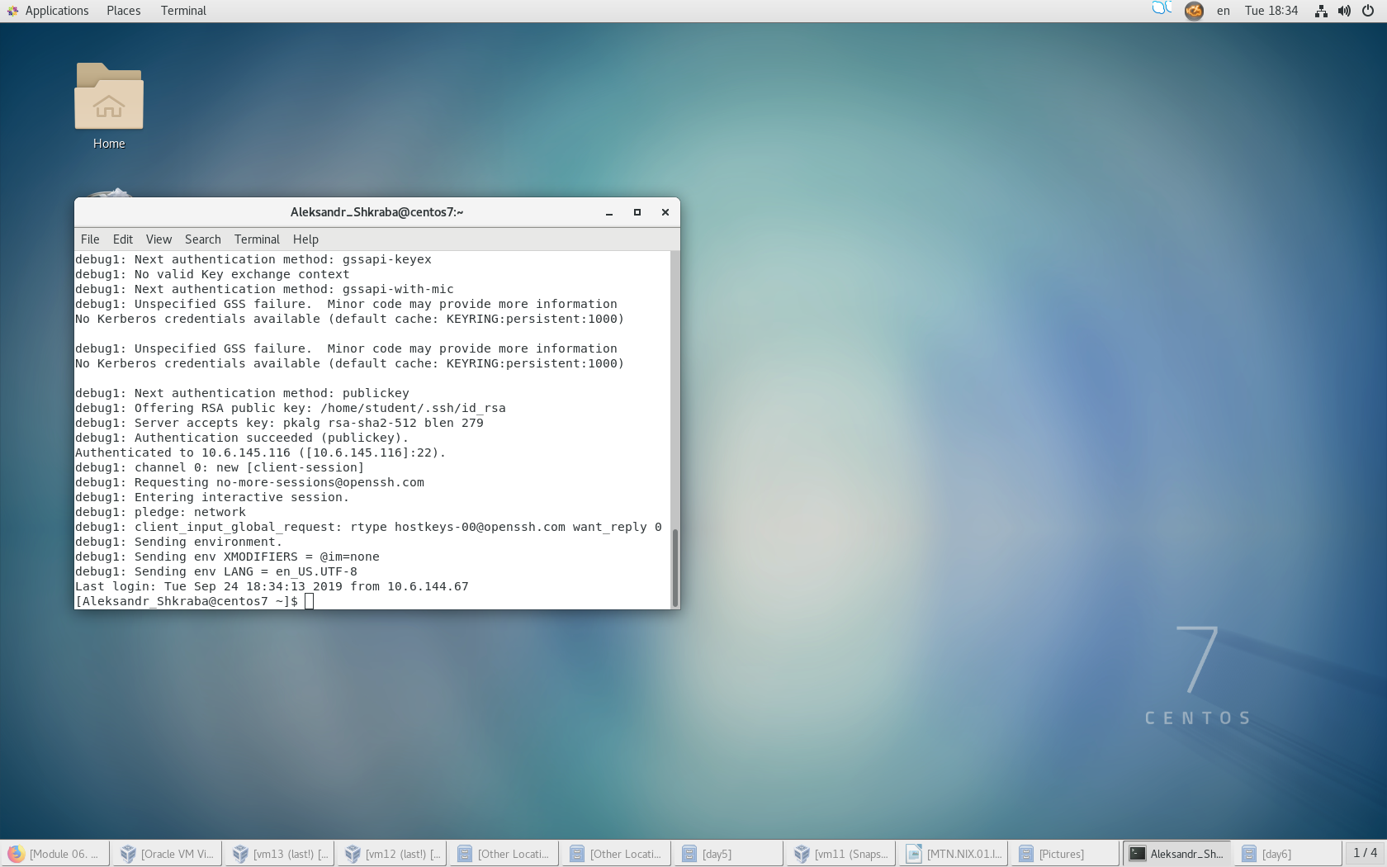

1. (as root) Create user mongo with primary group staff, UID=600, GID=600

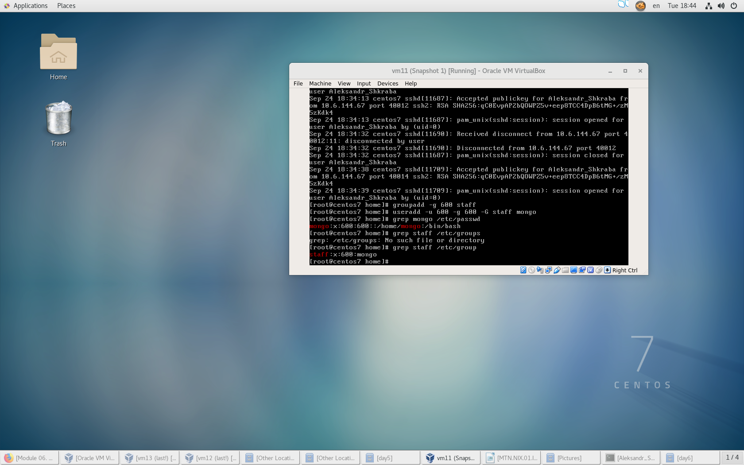

1. (as root) Create folders /apps/mongo/, give 750 permissions, set owner mongo:staff
2. (as root) Create folders /apps/mongodb/, give 750 permissions, set owner mongo:staff
3. (as root) Create folders /logs/mongo/, give 640 permissions, set owner mongo:staff

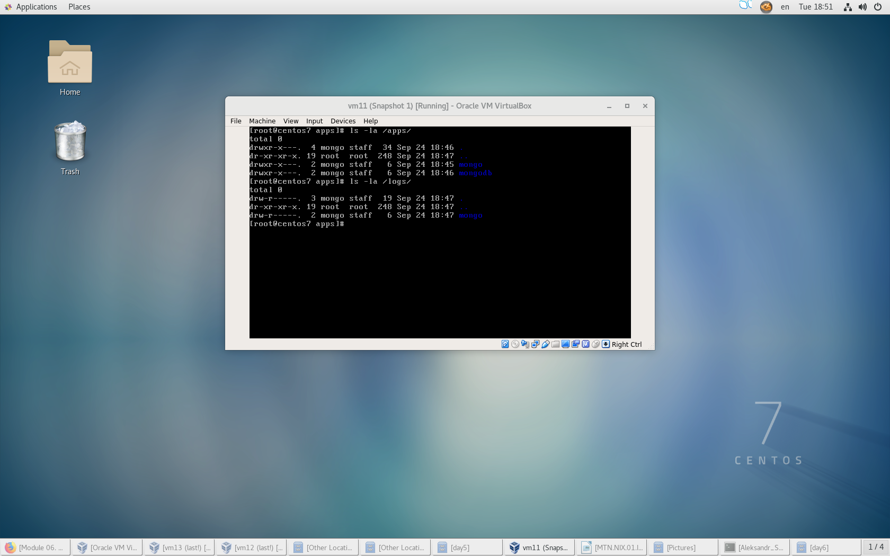

1. (as mongo) Download with wget <https://fastdl.mongodb.org/linux/mongodb-linux-x86_64-3.6.5.tgz>

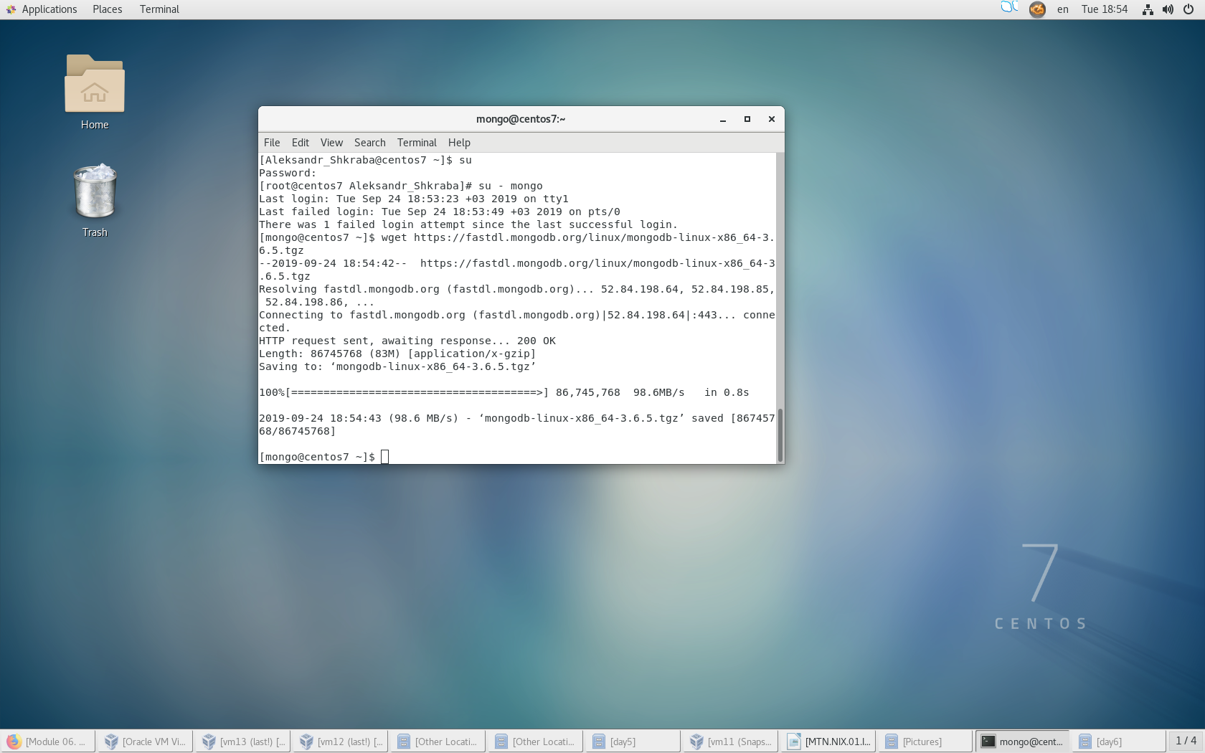

1. (as mongo) Download with curl <https://fastdl.mongodb.org/src/mongodb-src-r3.6.5.tar.gz>

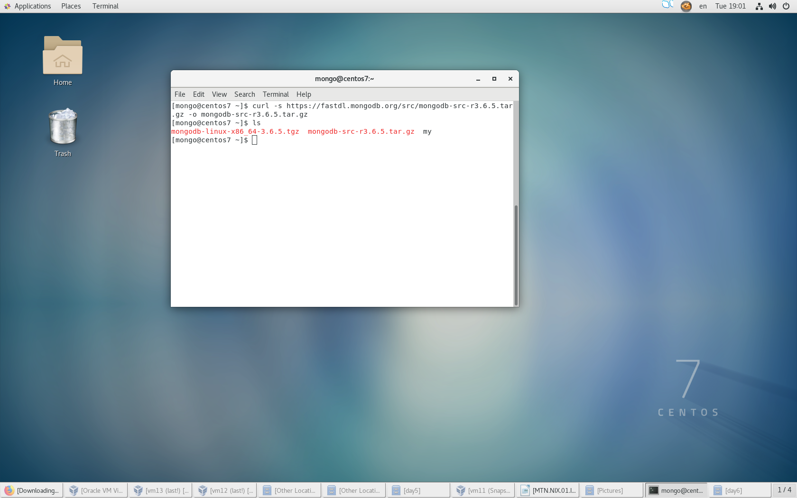

1. (as mongo) Unpack mongodb-linux-x86_64-3.6.5.tgz to /tmp/

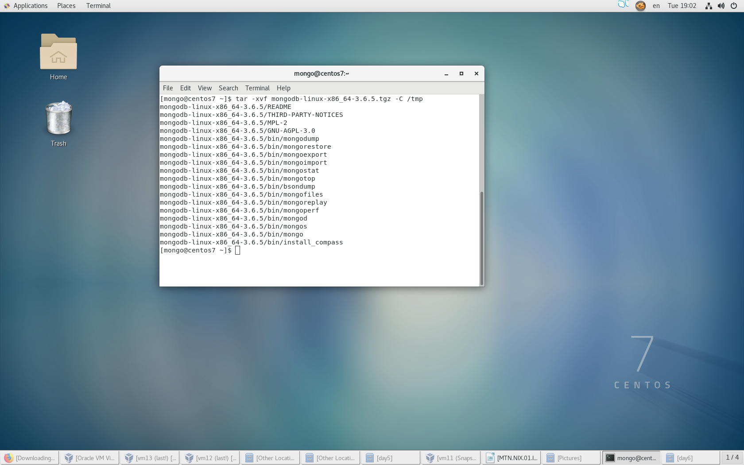

1. (as mongo) Unpack mongodb-src-r3.6.5.tar.gz to /tmp/

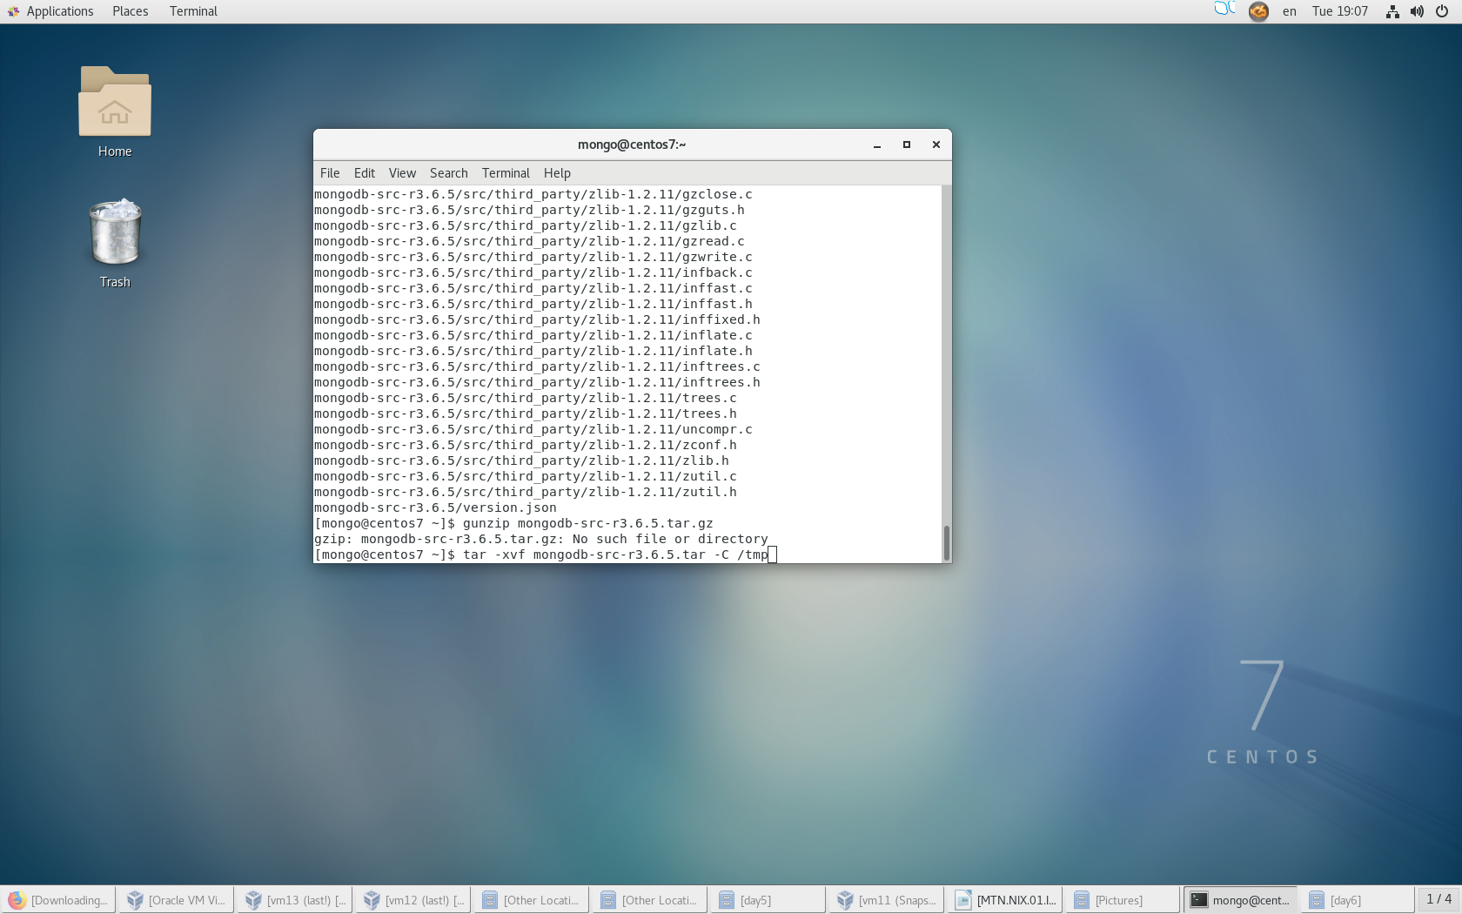

1. (*) Build mongodb from mongodb-src-r3.6.5
2. (as mongo) Copy ./mongodb-linux-x86_64-3.6.5 /* to /apps/mongo/

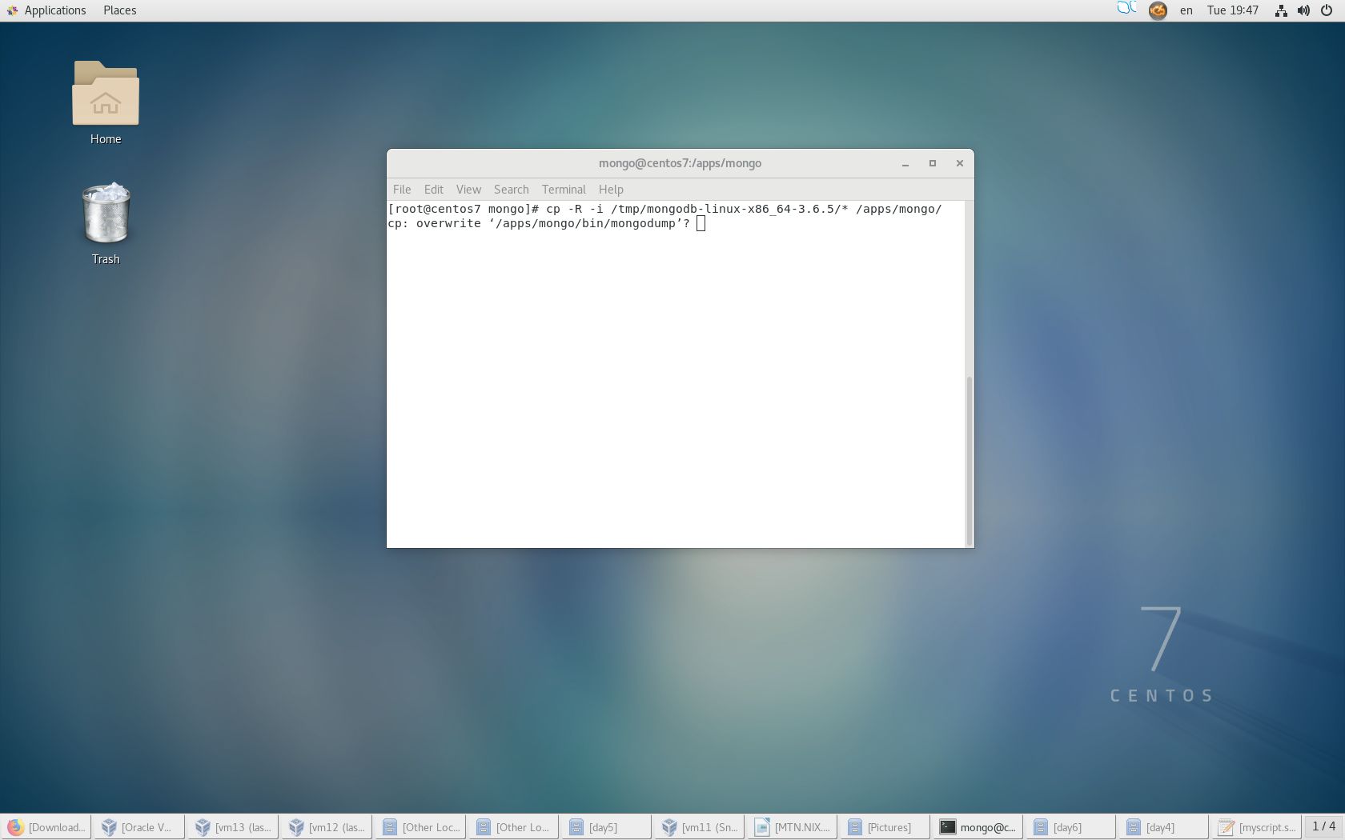

1. (as mongo) Update PATH on runtime by setting it to PATH=<mongodb-install-directory>/bin:$PATH

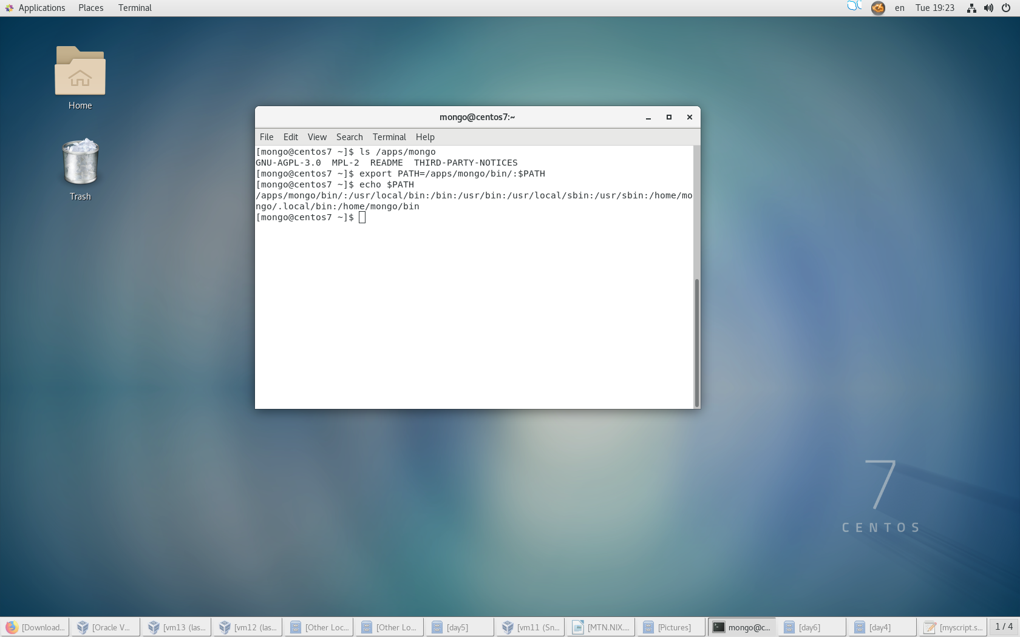

1. (as mongo) Update PATH in .bash_profile and .bashrc with the same ( добавил потом тоже самое для других пользователей и roota)

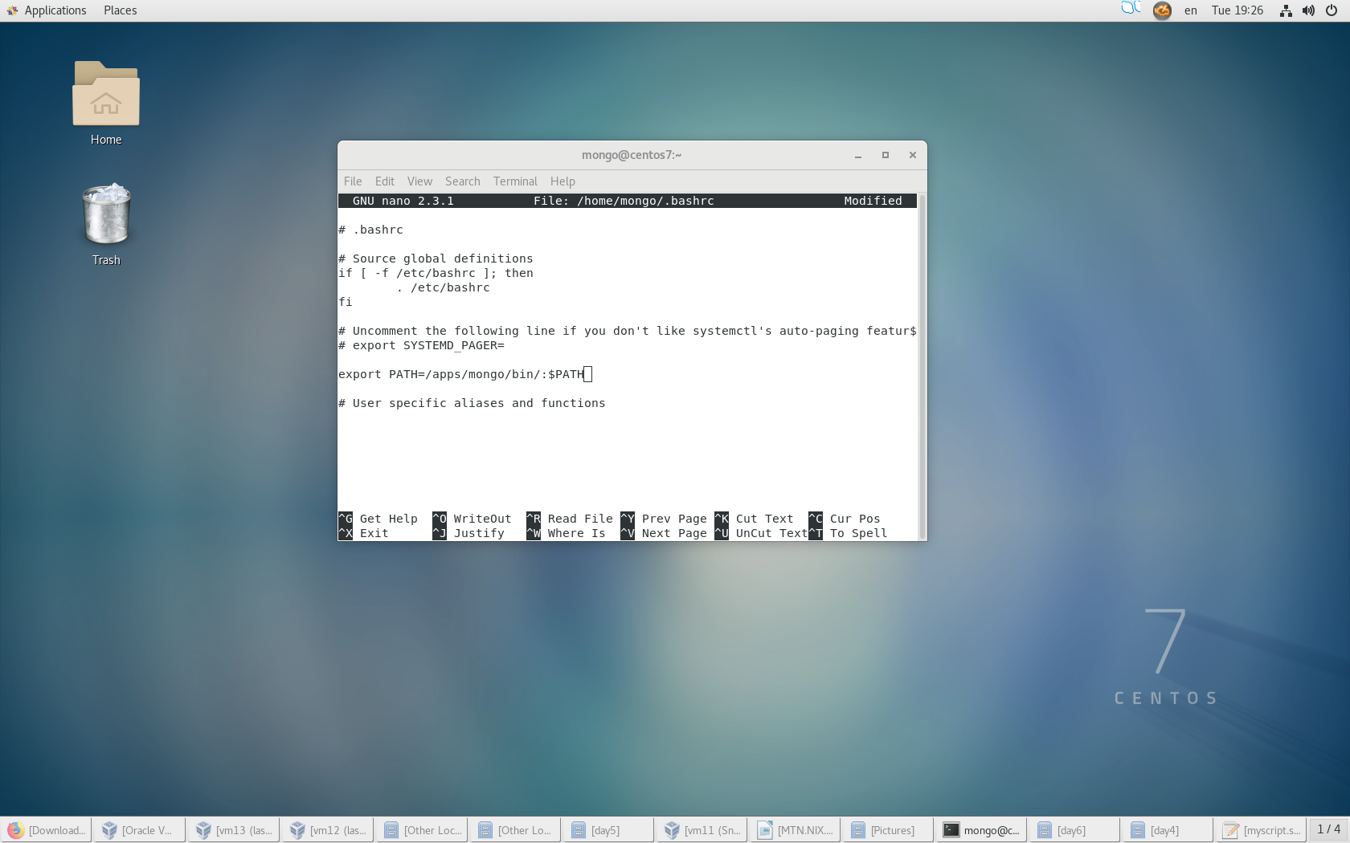

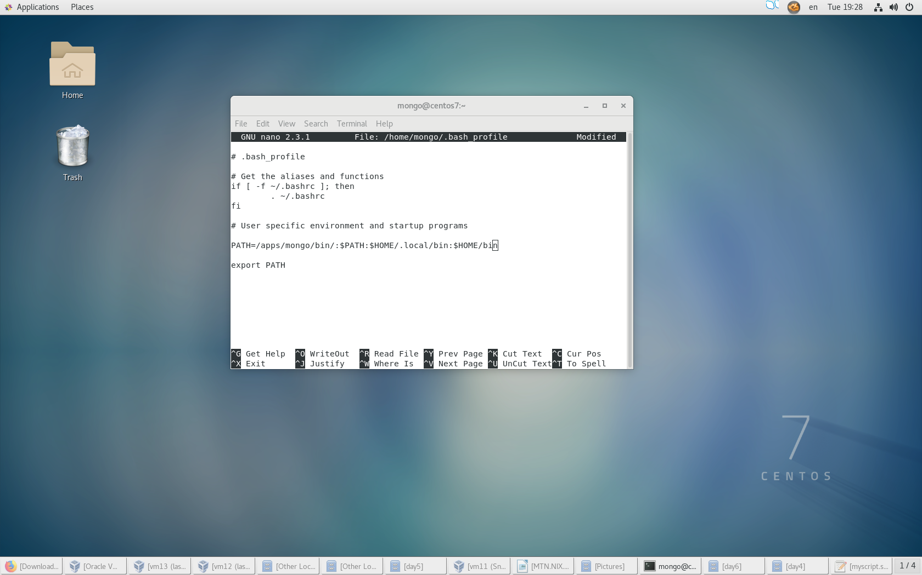

1. (as root) Setup number of allowed processes for mongo user: soft and hard = 32000

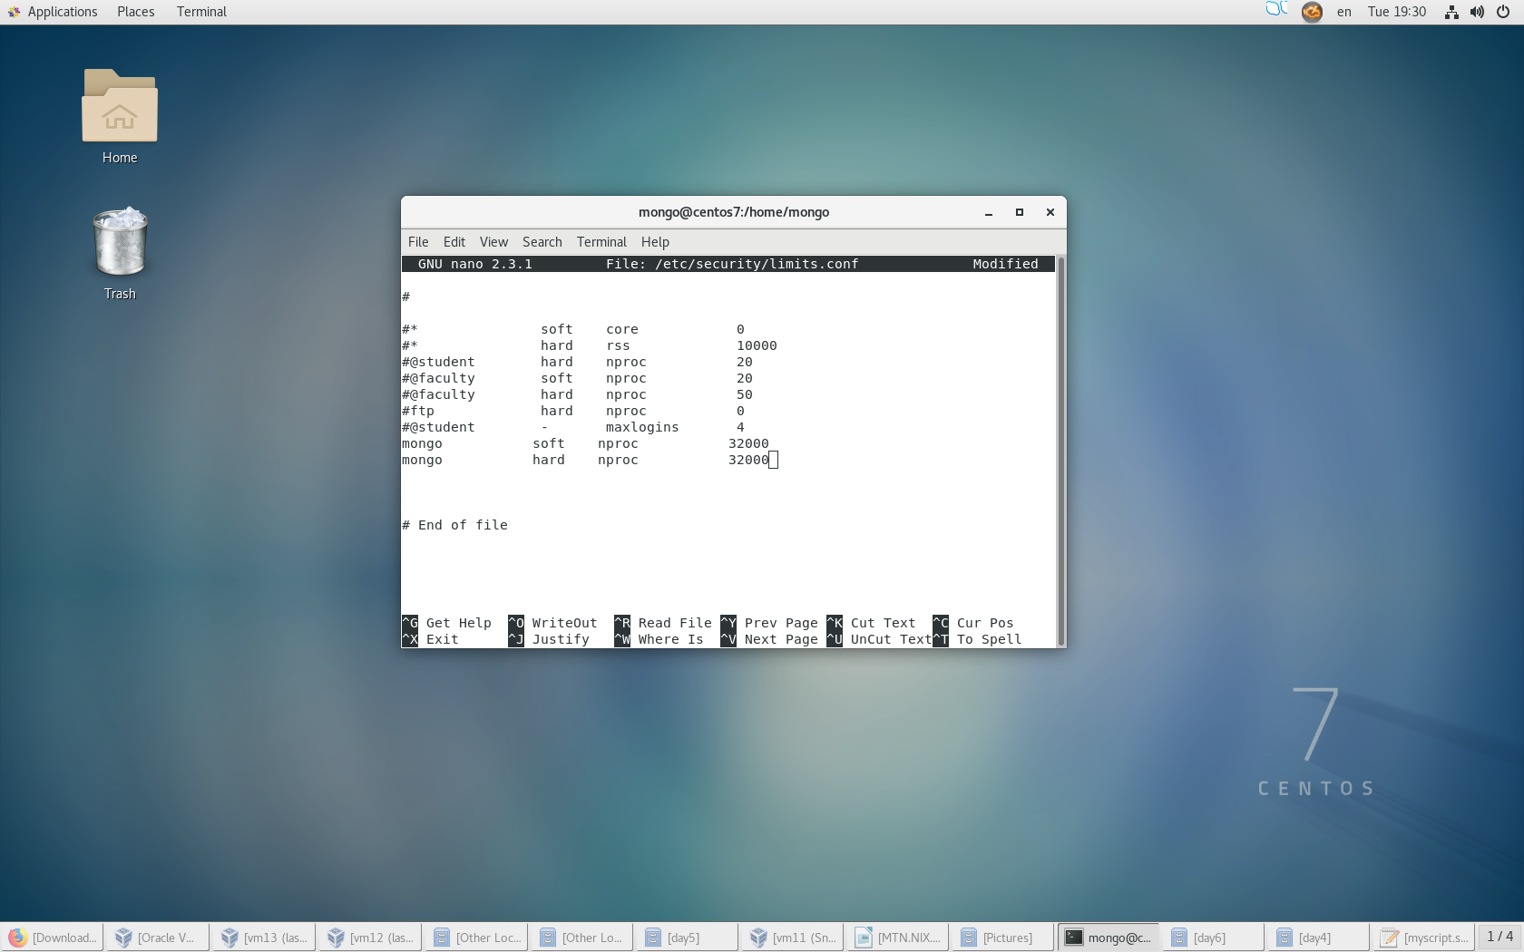

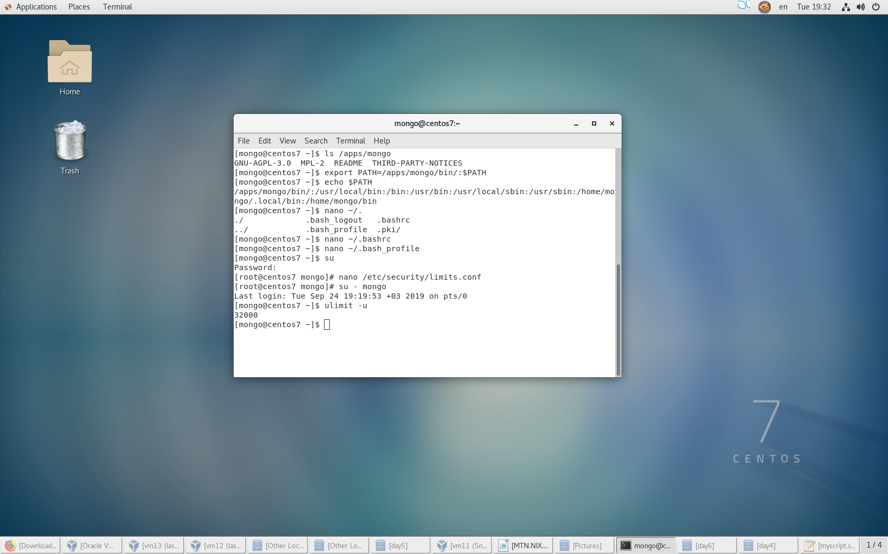

1. (as root) Give sudo rights for Name_Surname to run only mongod as mongo user

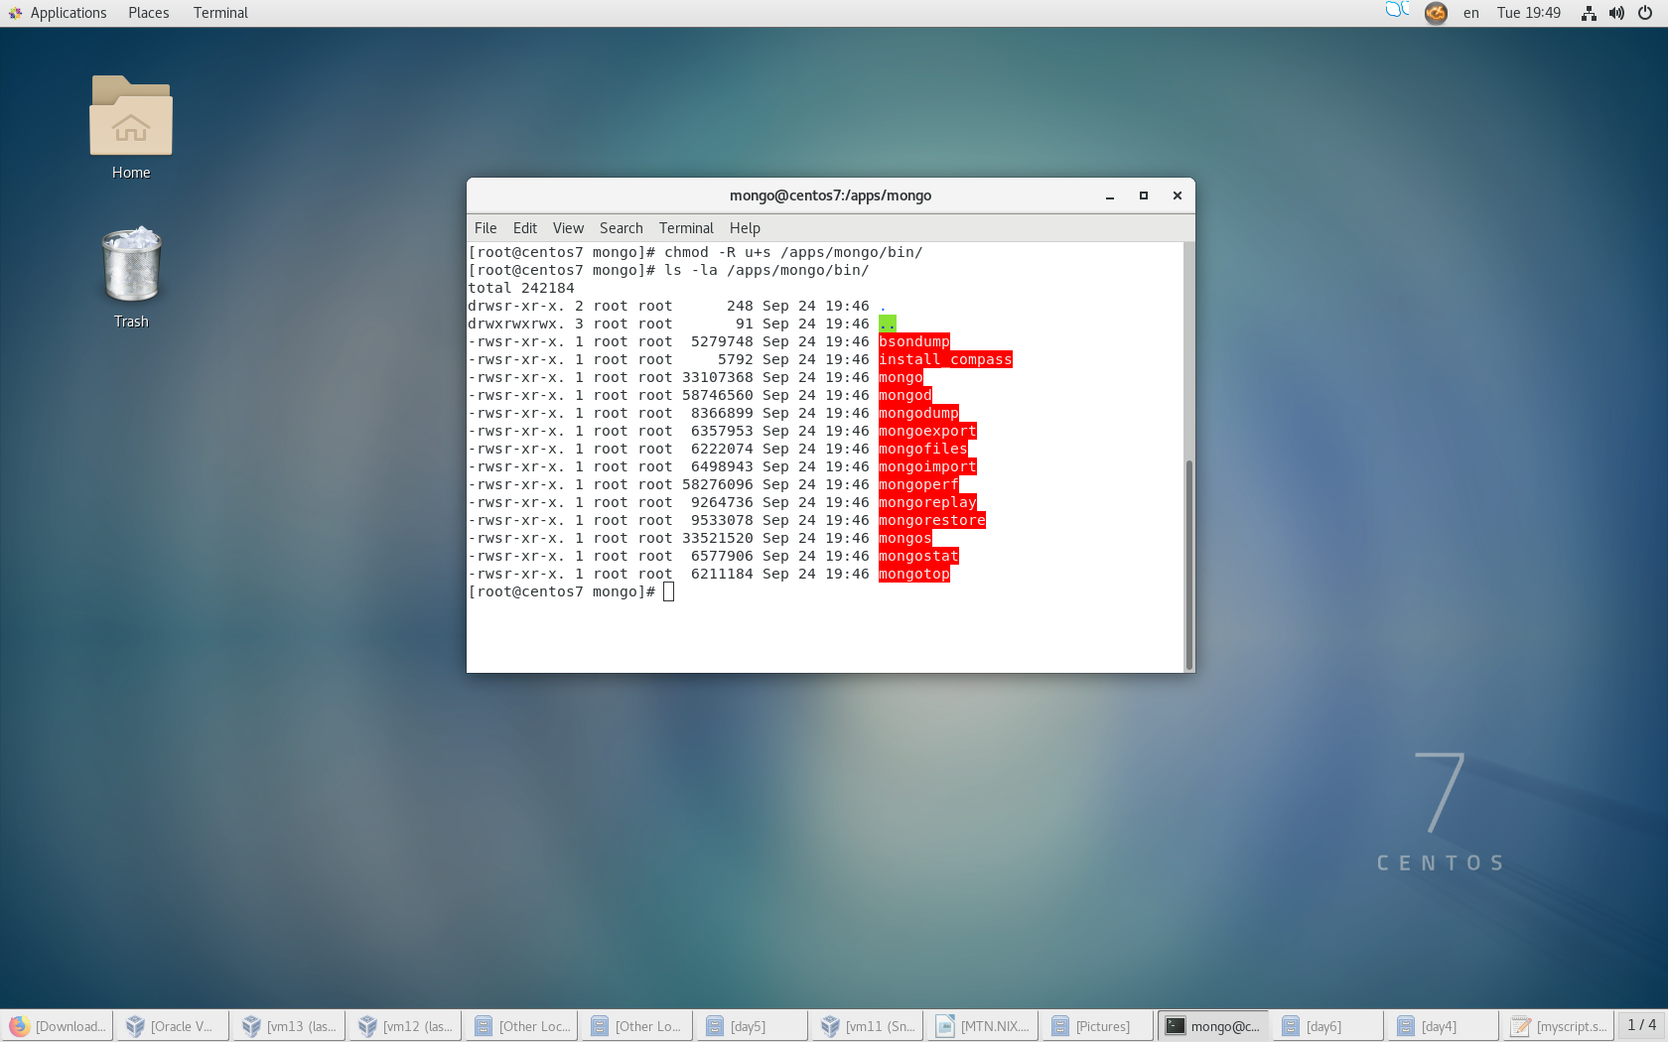



1. (as root) With user root check status for SELinux, disable SELinux if not disabled

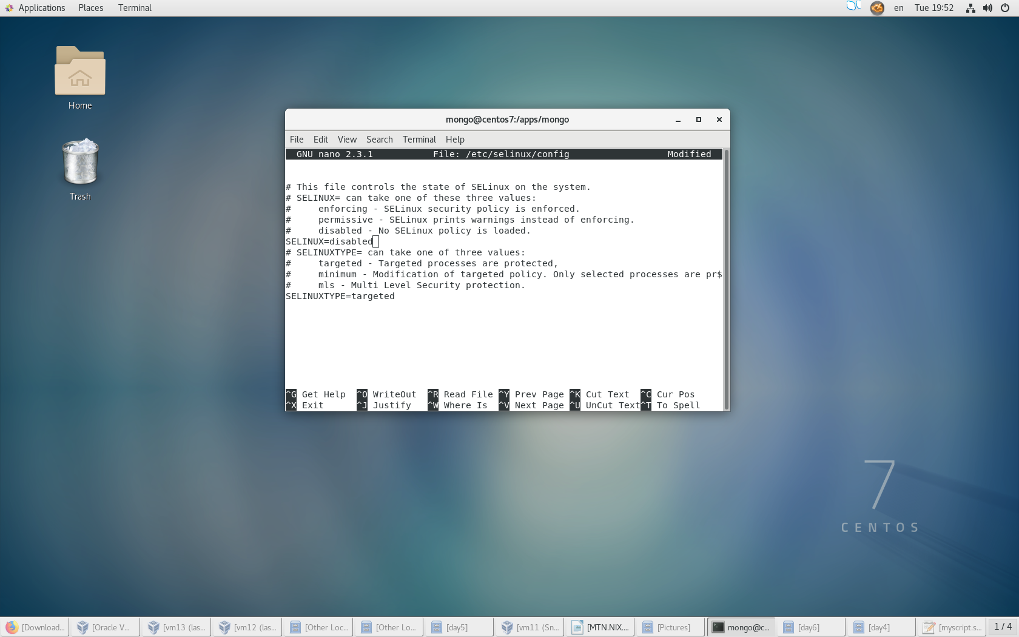

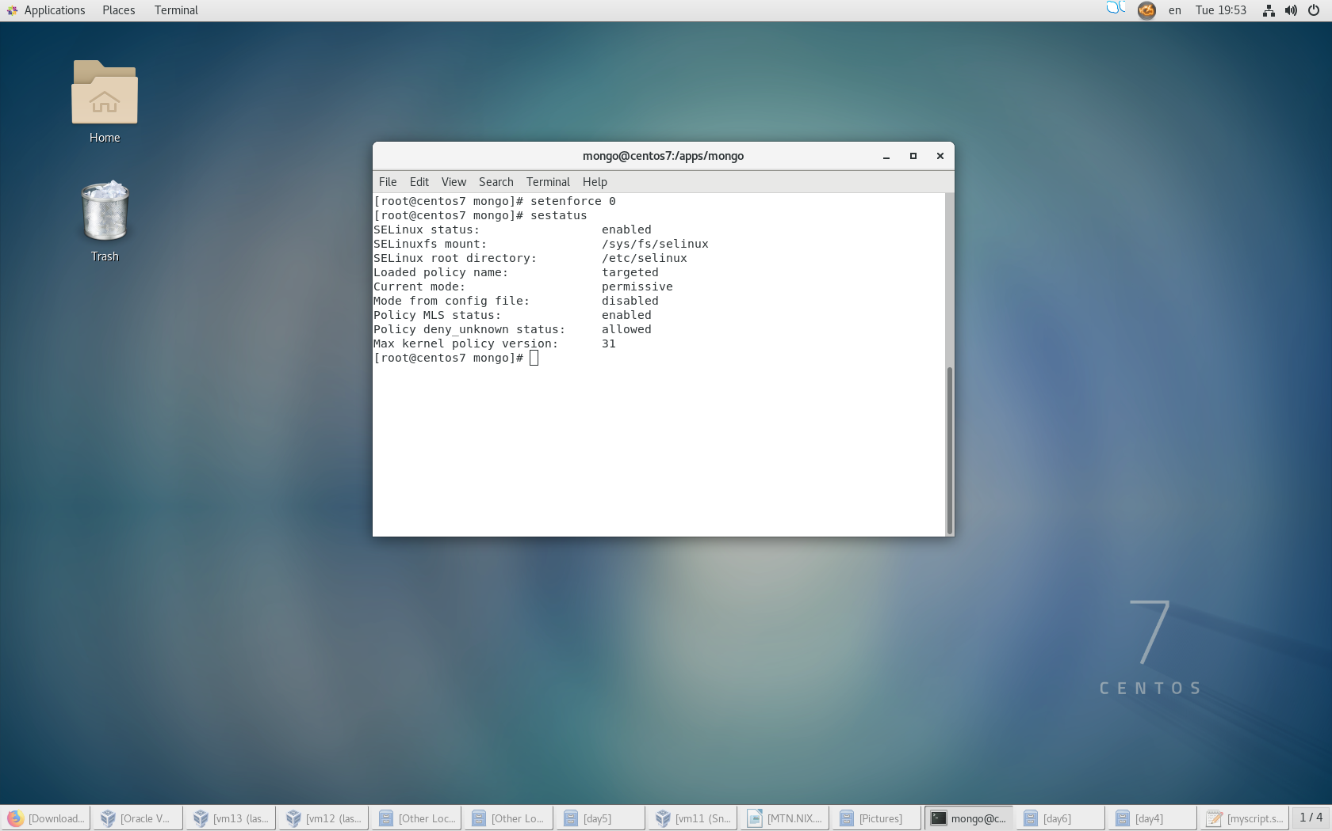

1. Run mongod from Name_Surname
2. Prove that process is running

* PID exist
* Corresponding [initandlisten] message in mongo log
* Port is really listening

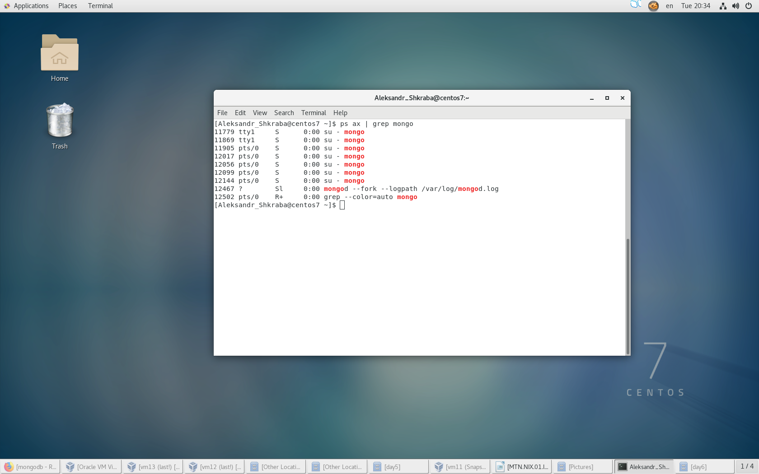

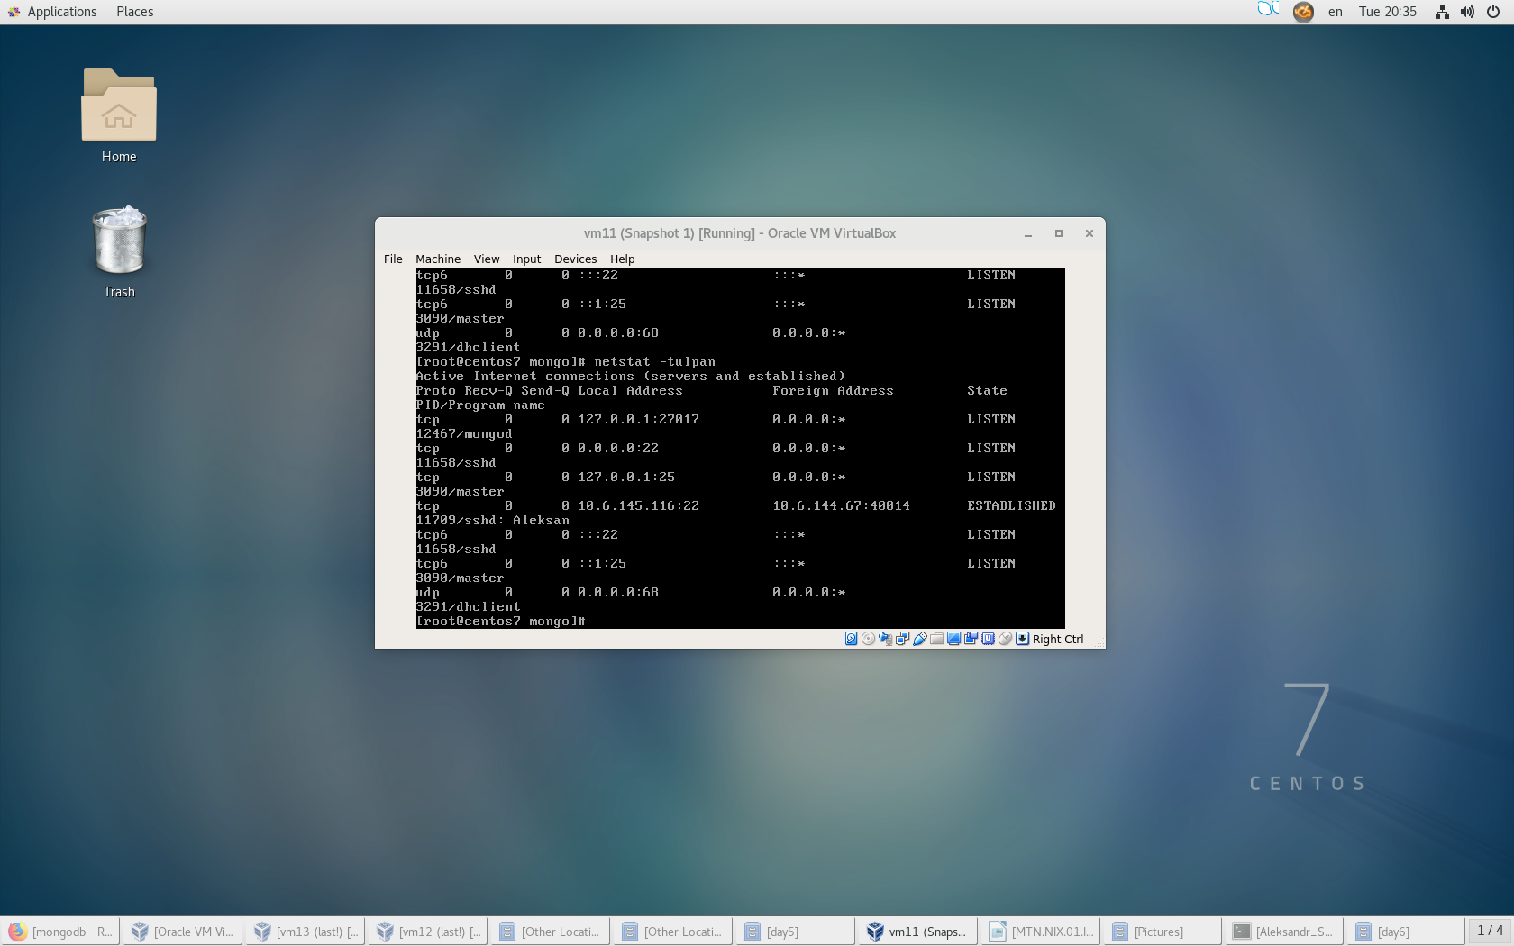

1. Stop the process

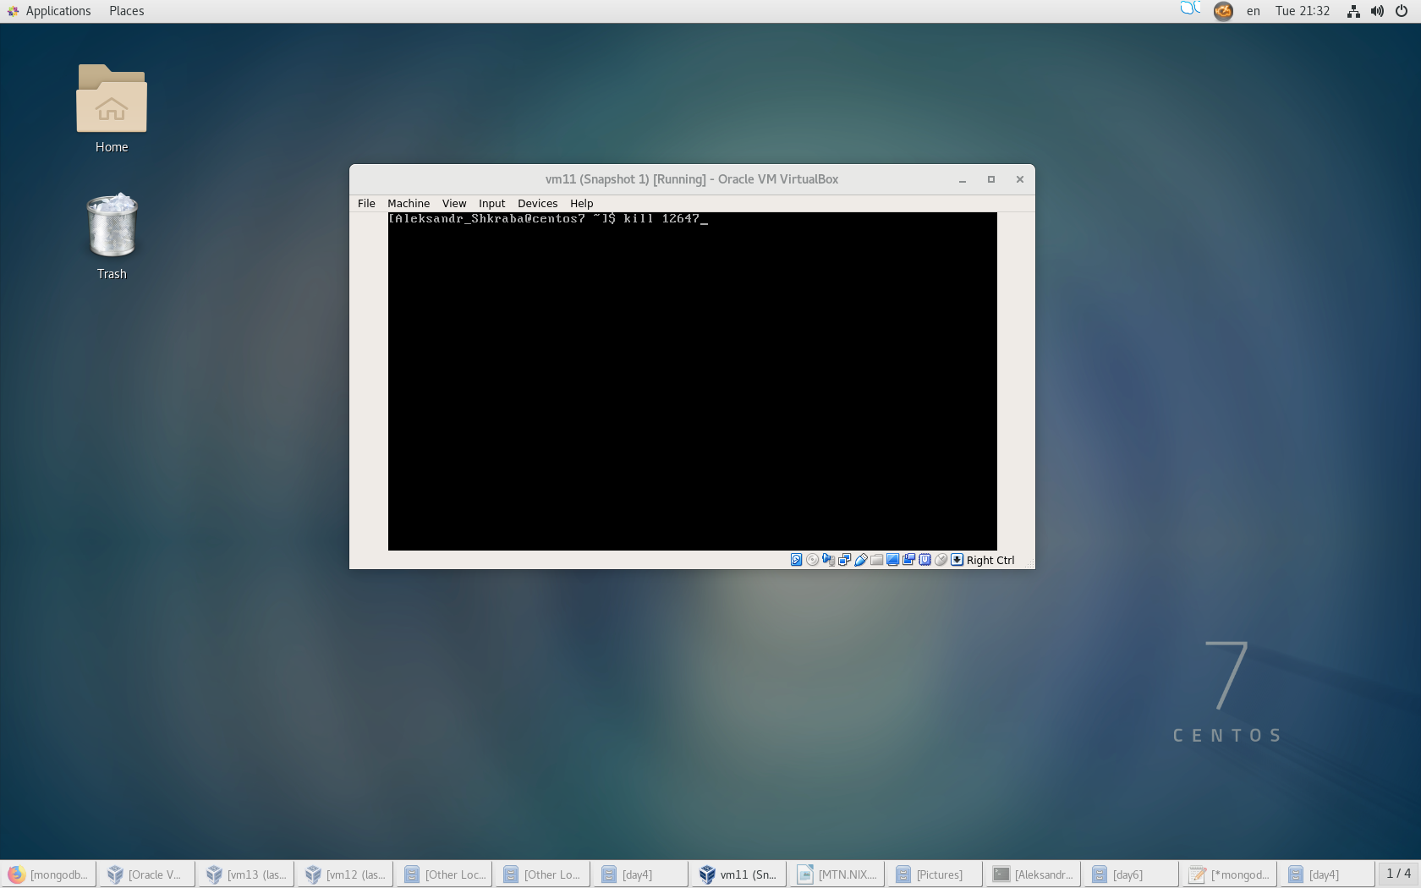

1. Create mongo.conf from sample
2. Replace systemLog.path and storage.dbPath with /apps/mongodb/ and /logs/mongo/ in mongod.conf using sed or AWK

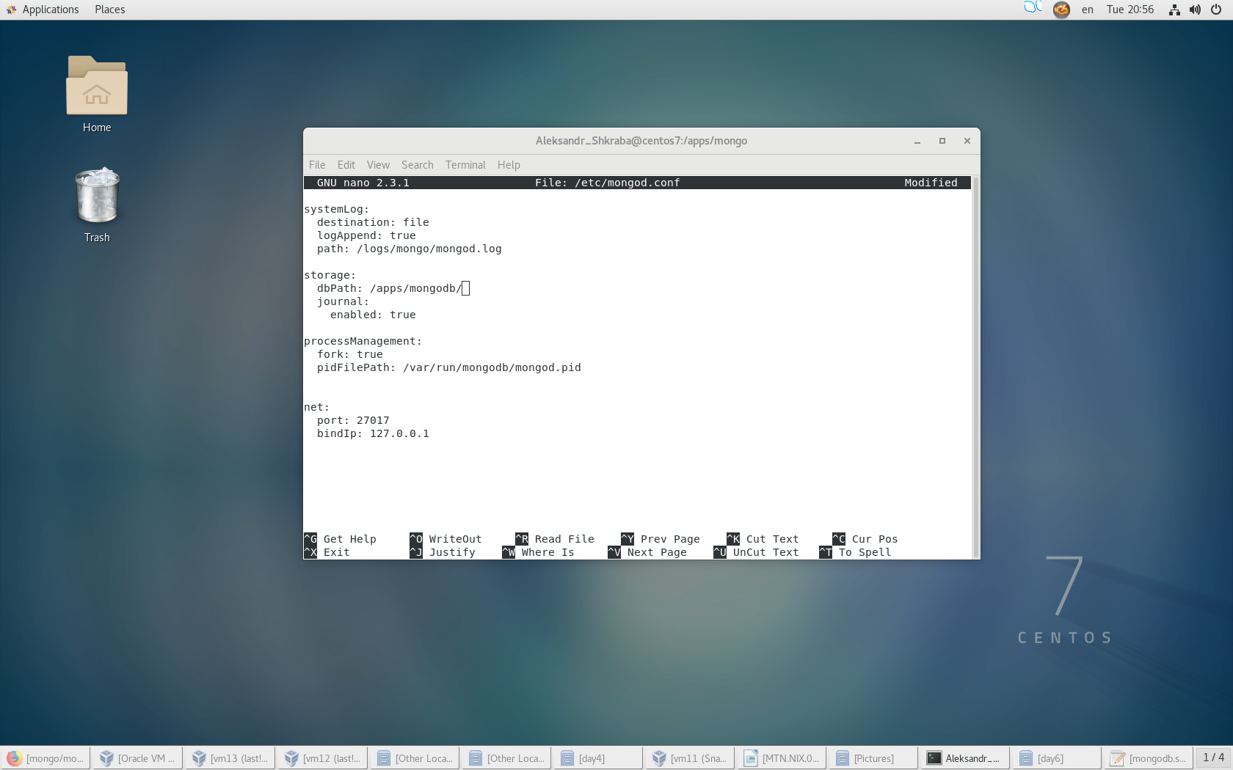

1. Create SysD unit file called mongo that will do. Save script, add mongo to autostart, verify that systemd script is working.

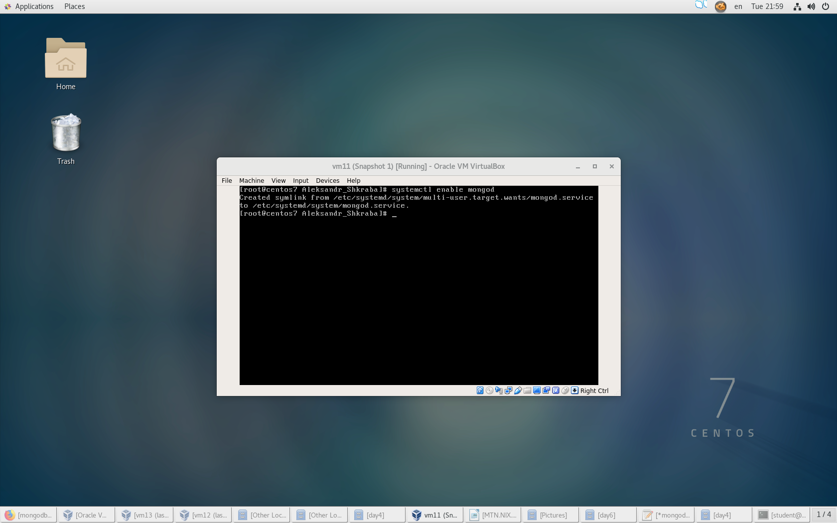

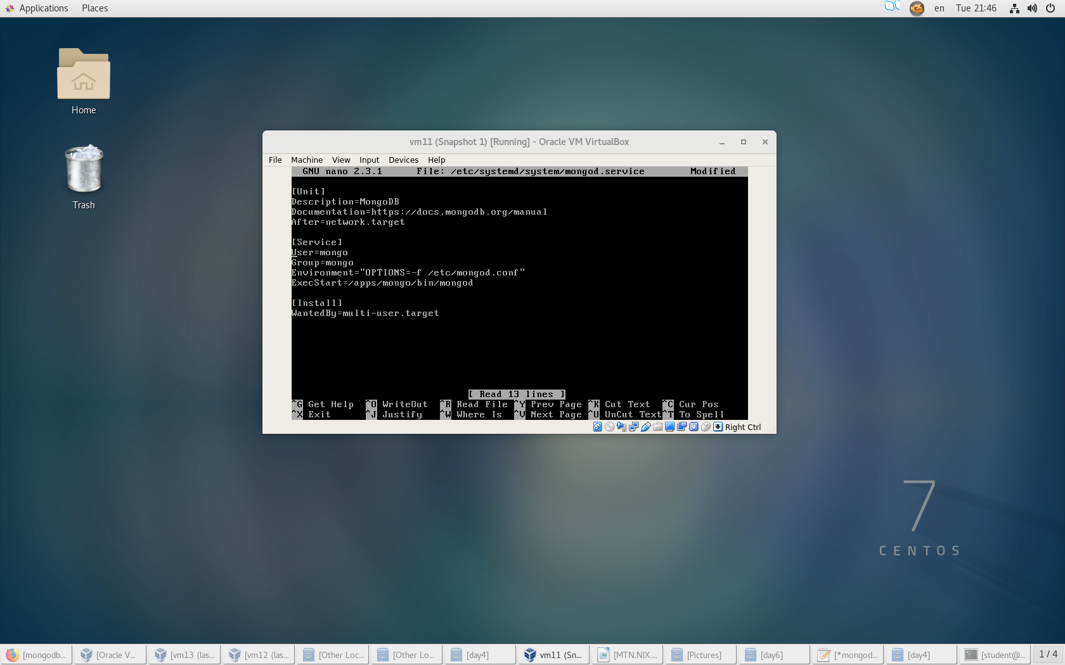

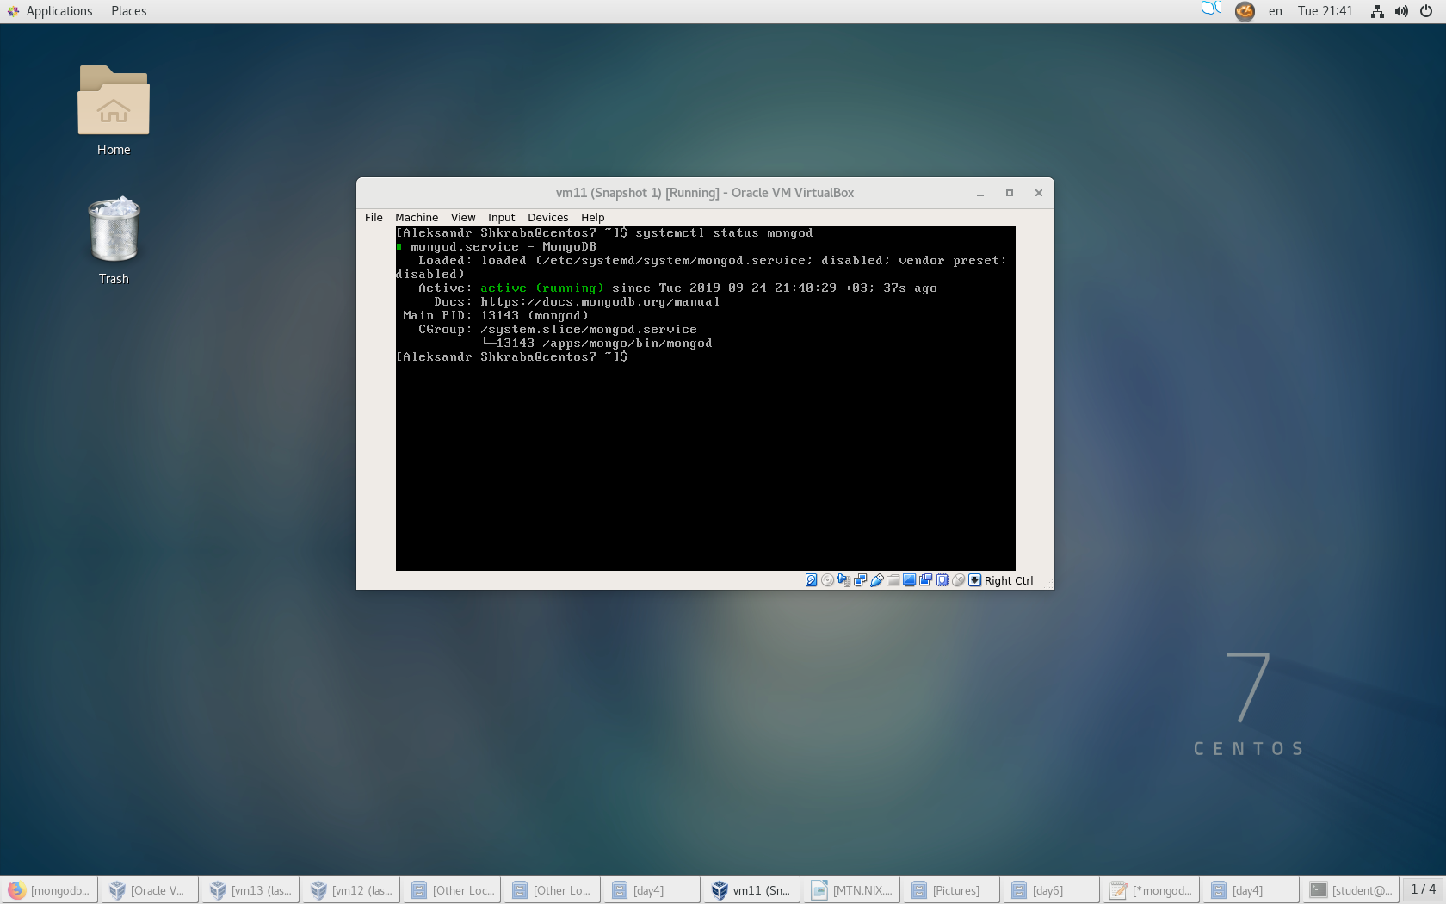

Start: Check if file /apps/mongo/bin/mongod and folders (/apps/mongodb/ and /logs/mongo/) exist, check if permissions and ownership are set correctly, if all OK – verify if process already running – if running, show the status, if NOT – start mongod.

Stop: get the process ID, kill the process, verify that no mongod processes are running and post proper message

